**SPECIFICATION SHEET (Belgium): AEROO**

*Version 07/03/2024*

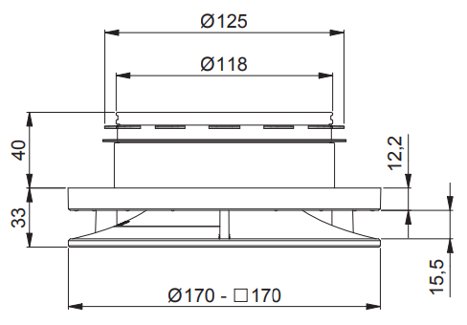**AEROO** is an adjustable design valve for both pulsion and extraction. AEROO’s aerodynamically refined design makes it the quietest on the market.

**MATERIAL**

Material: ASA UPVC

Dimensions:

* Valve connection: Ø125 mm
* Front plate: round Ø170 mm/square 170 x 170 mm

Colour: RAL 9010 (coating can be applied on top)/9005

Mounting: self-clamping rubber

**SPECIFICATIONS**

∫One valve for both pulsion (up to 90 m³/hr) and extraction (up to 100 m³/hr)

Maximum airflow

* Pulsion side up to 90 m3/h at 21 dB(A)
  + bedroom: up to 75 m3/h at <10 dB(A)
* Extraction side from 100 m3/h at 26.5 dB(A)

Acoustic aspects= Extremely quiet:

* At 90 m³/h pulsion 21 dB (A) in open position without air blocker
* At 100 m³/h extraction 26.5 dB (A) in open position without air blocker

Lowest resistance (in open position) = reduction of central unit energy consumption and noise production

* Pressure drop of 8 Pa in open position and without air blocker at 90 m³/h flow
* Pressure drop of 14 Pa in open position and without air blocker at 100 m³/h flow

Air flow:

* Perfect Coanda pulsion technology ensures comfort and avoids draughts

Endlimit settings:

* Valve with 50 finely tunable endlimit settings while still maintaining whisper-quiet operation throughout a wide operating range
* 2 regulation methods
  + Manual dial with pre-printed letters for better visibility
  + Adjusted key opening for use of setting tool from ground floor

= no ladder necessary

Regulation optimisation (optional)

* Automatic calculation of regulation position per valve possible via algorithm (in combination with high-performance demand-driven D+ ventilation units)

Installation:

* Double function sealing ring
  + Fixing the valve & sealing it airtight
  + no tools or mounting materials required for installation
* Valve assembled and in ‘open position’ in packaging *= time saving & installation-ready*
* Immediately ready for initial measurement after installation
  + Front plate loose in packaging *= time savings & no damage during installation*

Cleaning and maintenance:

* Easily removable front plate, without having to remove the connection
  + Valve retains settings during cleaning
  + No damage to ceiling upon removal

**REFERENCES**

|  |  |  |
| --- | --- | --- |
| Valves | White (RAL 9010) | Black (RAL 9005) |
| Aeroo Round | 17147 | 17831 |
| Aero Square | 17148 | 17832 |
| Aeroo Round bulk packaging | 30880 | - |

|  |  |
| --- | --- |
| Accessories |  |
| Aeroo Air blocker | 12158 |
| Aeroo set-up help | 17149 |